Cellular Brain Repair for Parkinson’s Disease: Is the Answer in the (Biomaterial) Matrix?
¹Pharmacology & Therapeutics and ²Galway Neuroscience Centre, National University of Ireland Galway (NUI Galway), Galway, Ireland

Cell-based brain repair is a promising option for Parkinson’s disease (PD) whereby the nigrostriatal dopaminergic neurons that have degenerated over the course of the disease are replaced by transplantation of healthy neurons into the brain. Given that cell-based brain repair is rapidly accelerating towards the clinic, with the ongoing TRANSEURO trial of fetal tissue and the recently announced Takahashi trial of iPSC-derived dopaminergic neurons in Japan, but that the margin for improvement of such approaches is great, it is critical to continue rigorous preclinical studies to identify potential methods of improving the outcome of cell-based brain repair for patients.

In this context, we will be presenting our recent data demonstrating that dopaminergic cell replacement in the Parkinsonian rodent brain, using fetal-derived cells, is dramatically enhanced when the cells were transplanted in a neurotrophin-enriched, immune-shielding collagen hydrogel [1-3]. The hydrogel provided the transplanted neurons with 1) a physical scaffold for cell-matrix adhesion, 2) a neurotrophin reservoir for sustained neurotrophin exposure after transplantation, and 3) shielding from the deleterious effects of the host microglial and astroglial innate immune response (Fig. 1). We will also present data from studies encapsulating human iPSC-derived dopaminergic neurons.

Overall, this work suggests that the clinical transplant field should move towards the incorporation of biomaterials, such as neurotrophin-enriched collagen hydrogels, into future clinical trials using primary and/or iPSC derived neurons. Improving the safety and efficacy of such approaches, using this minimally invasive and injectable hydrogel that offers a neuroprotective and immune shielding microenvironment to the transplanted cells, could dramatically improve the reparative capacity of cell therapy for PD, and ultimately lead to an improved therapy for patients.

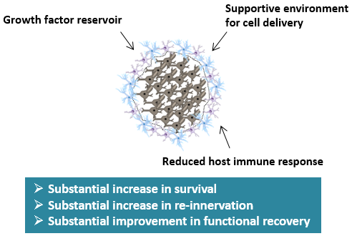

Fig. 1. Impact of the neurotrophin-enriched collagen hydrogel on dopaminergic transplants.

ACKNOWLEDGEMENTS: Financial support was received from Science Foundation Ireland, (Grant/Award Number: 11/RFP/NES/3183), H2020 Marie Sklodowska-Curie Actions (Grant/Award Number: 676408) and the Michael J Fox Foundation for Parkinson’s Research (Grand/Award Number: MJFF17244).

REFERENCES
[1] Moriarty et al. Sci Rep, 2017; 7, 16033.
[2] Moriarty et al. Eur J Neurosci. 2019; 49, 487-496.
[3] Moriarty et al., Eur J Neurosci. 2019; 49, 472-486.

